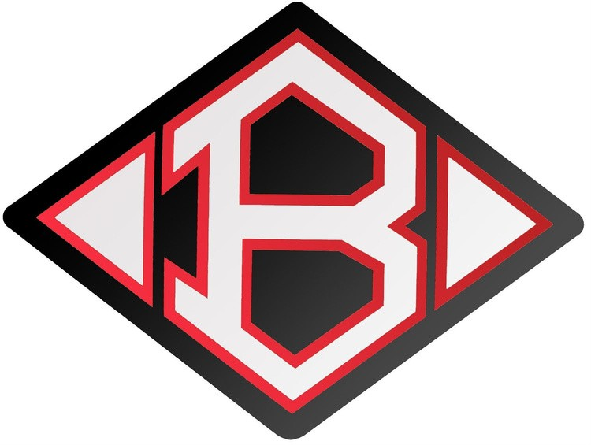
Clear Brook High School Celebrities Dance Team
Invites You to Join Us for the
2022 - 2023

Junior Celebrities Fall Clinic!
This fall the Clear Brook Celebrities are inviting you to dance with us on the Challenger Columbia Stadium field! We will teach you a dance that you will get to perform with the Celebrities at pre-game. You will then get to participate in the stands for the first half of the game.

Time:
Clinic - 8:00 AM - 1:00 PM (parent preview at 12:30 PM)
Game - 7:00 PM
(Dancers will need to arrive at 6:00PM to sign in and get ready).

Cost:
$60 (includes clinic t-shirt to wear at
performance and participant admittance into the game).
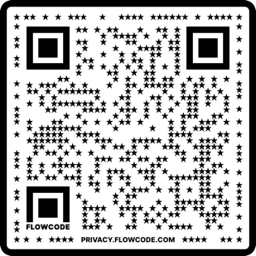
Registration Link:
https://tinyurl.com/2eh4rf7v
Checks Made Out To:
Clear Brook Celebrity Booster Club

PayPal Link
https://tinyurl.com/2p8c2h2y
Ages:
5-15 (Kinder - 9th Grade)

When?:
Clinic - Saturday, October 22nd
Game - Friday, October 28th

Where?:
Clinic - Clear Brook High School
Game - Challenger Columbia Stadium

Mail Your Payments To:
Clear Brook High School Attn: Ash Cook
FM 2351
Friendswood, TX 77546
Registration Deadline:
Friday, October 7th, 2022

Name: Age:
Shirt Size: YS YM YL YXL AS AM AL AXL
Parent/Guardian Name:
Parent/Guardian Phone #:
Parent/Guardian Email:
Would you like to be put on our email list for future events?: YES NO
Did a Celebrity Inform you? YES NO If yes, which Celebrity?
My daughter/son has my permission to attend the Clear Brook Celebrity Junior Celebrity Events on October 22nd & 28th, 2022. I understand that my child's photo may appear on the Celebrity website, but that no names, first or last will be given. I hereby authorize the Dance Clinic Staff to act for me according to the best judgement in any emergency requiring medical attention. I hereby waive and release CBHS, the Celebrity Directors, and the Celebrity Booster Club from any liability for any injuries while my child is in attendance.
Parent Signature: Date:
If you have any questions, email Mr. Cook at ascook@ccisd.net

